Yuva Intern-week -2
EDA and visualization framework design

Student name: Sanjay V P

Project Report: Exploratory Data Analysis (EDA) and Visualization Framework Design

- Introduction to EDA
Exploratory Data Analysis (EDA) is a crucial initial step in any data science and analytics workflow. Before building machine learning models or making business decisions, EDA allows data analysts to understand the structure, underlying patterns, anomalies, and statistical properties of a dataset.

Importance in Data Science Projects
•Data Understanding: Helps in identifying variable types, values, and overall structure.
•Data Quality Check: Identifies missing values, duplicate entries, and inconsistent data formatting.
•Feature Selection & Engineering: Provides key insights on which features will be most informative for predictive modeling.
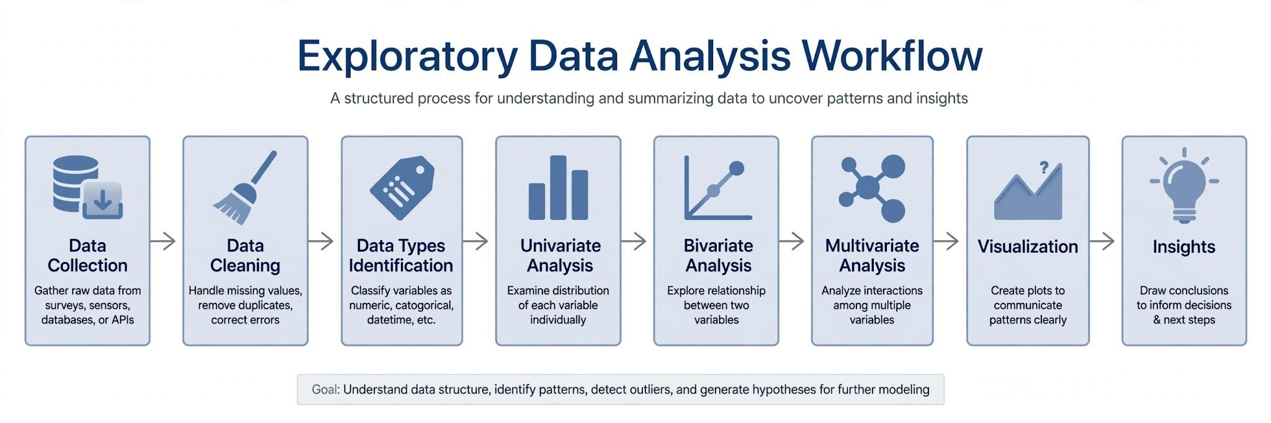
2.Potential Data Types & Exploration Techniques

Potential Data Types
1.Numerical Data:
• Continuous: Age, Salary, Temperature.
• Discrete: Product counts, Website visits.
2.Categorical Data:
•Nominal: Gender, Country, Payment Method.
•Ordinal: Ratings (Low, Medium, High), Customer Satisfaction Scores.
3.Time-Series Data: Timestamped data such as sales trends over months or daily stock prices.
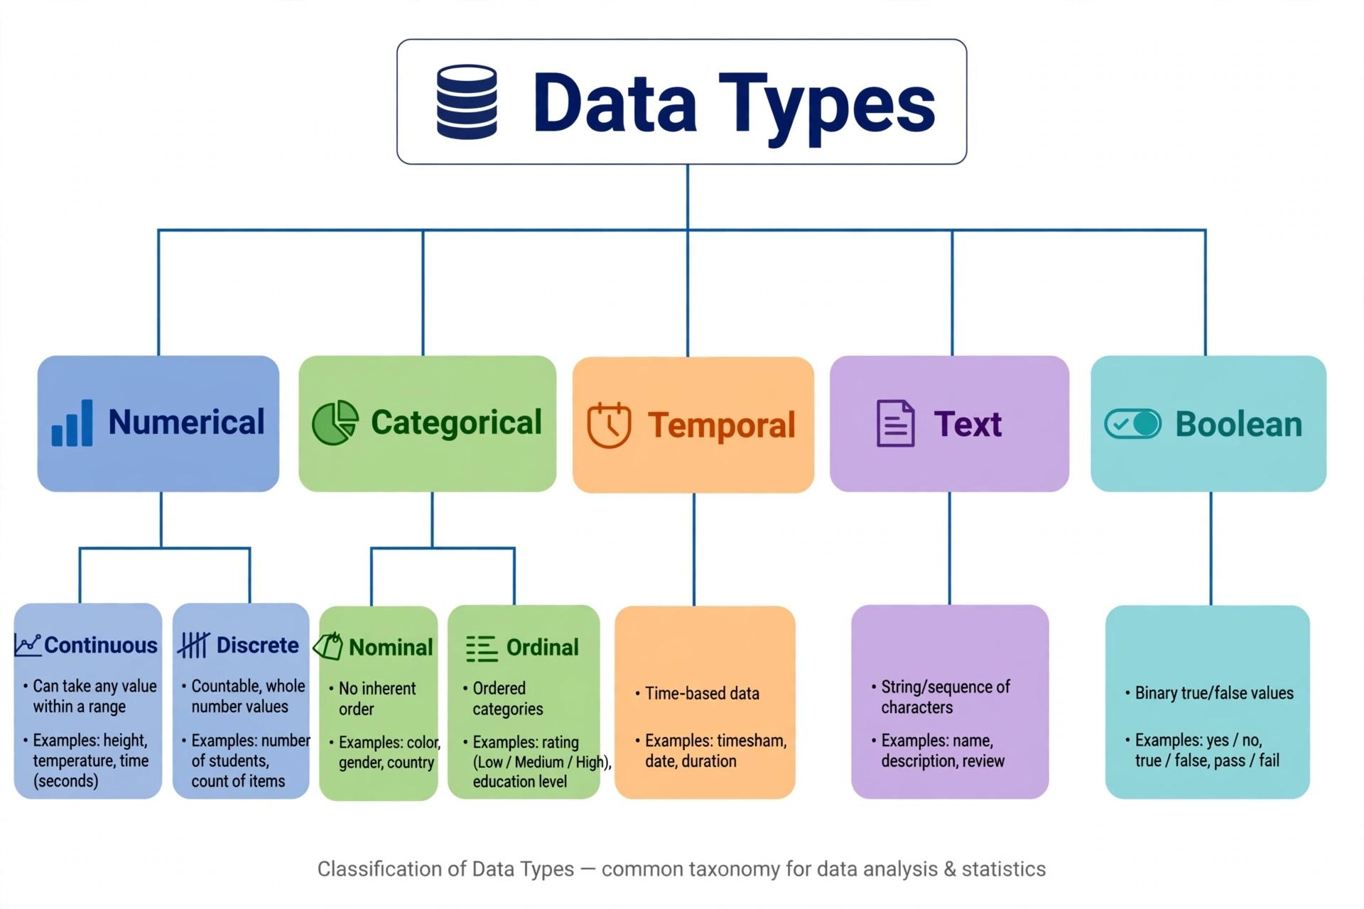
Data Exploration Techniques

A. Analysis Types

•Univariate Analysis: Analyzes individual variables to understand their distribution, central tendency, and spread (e.g., mean, median, standard deviation, histograms).

• Bivariate Analysis: Examines relationships between two variables to determine correlation or group differences (e.g., scatter plots, cross-tabulations).

• Multivariate Analysis: Explores interactions among three or more variables simultaneously (e.g., correlation matrices, pair plots).

B. Data Cleaning Methods
•Handling Missing Data:
•Mean/Median Imputation: For numerical variables with missing values.
•Mode Imputation: For categorical variables.
•Dropping Columns/Rows: Used when missing values exceed acceptable thresholds (e.g., > 50%).
•Handling Outliers:
•Detection: Using Box Plots, Interquartile Range (IQR) method, or Z-Score.
•Treatment: Capping/Winsorization, log transformations, or filtering out invalid entries.

3. Visualization strategies
Histogram: For Age and Cart Value distribution to see skewness.
> Bar Chart: For Categorical counts like Payment Method vs Purchase rate.
> Boxplot: To detect outliers in Session Duration and Cart Value.
> Scatter Plot: Session Duration vs Cart Value colored by Purchase to see clusters.
> Heatmap (Seaborn): Correlation matrix of all numerical features to find multicollinearity.
> Pie Chart: Device Type share (Mobile vs Desktop).
> Line Chart: Purchase trend over hypothetical time.
> All plots will be created using Matplotlib, Seaborn,and Plotly for interactivity.
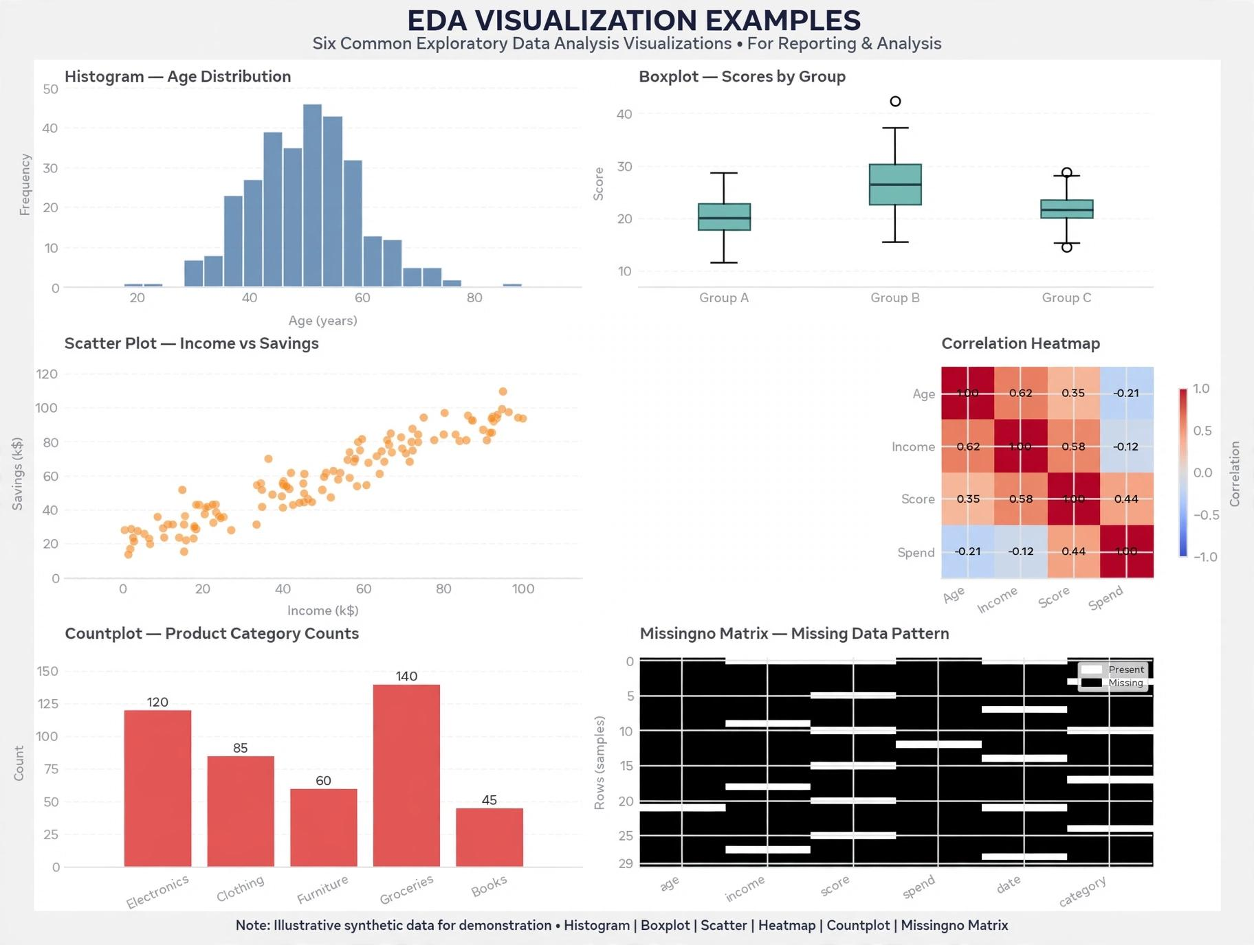
4. Tools and libraries
The framework utilizes standard Python libraries for data manipulation and visualization:
•Pandas:
Used for data loading, manipulation, handling missing values, and aggregation.
•NumPy:
Enables high-performance numerical operations and array manipulations.
•Matplotlib:
Used for foundational plotting, custom figure layouts, and standard charts.
•Seaborn:
Built on top of Matplotlib, provides high-level statistical graphics like heatmaps and box plots.
•Plotly :
Creates interactive plots for web presentations and dashboards.
5. Planning for documenting and reporting result
To effectively communicate findings to technical and non-technical stakeholders, the report will follow this structure:
1.Executive Summary: Highlights key findings, objectives, and overall business takeaways.
2.Dataset Summary: Provides details on dataset dimensions, column descriptions, and data types.
3.Data Preprocessing Log: Documents how missing values, anomalies, and outliers were handled.
4.Key Visual Insights: Summarizes main visualizations (distributions, correlations, trends) with brief explanations.
5.Conclusion & Recommendations: Provides actionable insights and next steps for machine learning modeling or strategic planning.

